Add/customize brand into casafi6(client)

Casafi6 is web platform that is white label.  
So we can add new brand or customize existing brand using env and white-label.config.js  
  
Overview  
  
We have white-label.config.js in project root that contains brand list.  
Here we can specify site name, logo, icon, color pallet, and so on.  
The brand can be selected by specifying VUE_APP_WHITE_LABEL_BRAND in corresponding .env file that is used for to build.  
  
Customize brand

1. How to specify brand which app will be built for.

We can specify brand by setting VUE_APP_WHITE_LABEL_BRAND in the .env that is used for to build.   
The value of VUE_APP_WHITE_LABEL_BRAND should exist as key in white-label.config.js.

For example:  
Let’s assume we need to build as local.mortgagecomposer.com with mortgagecomposer brand.  
in this case, we use .env.local-mortgagecomposer-remote-go  
in this env file we need to specify VUE_APP_WHITE_LABEL_BRAND=mortgagecomposer  
the value(mortgagecomposer) is just key in white-label.config.js

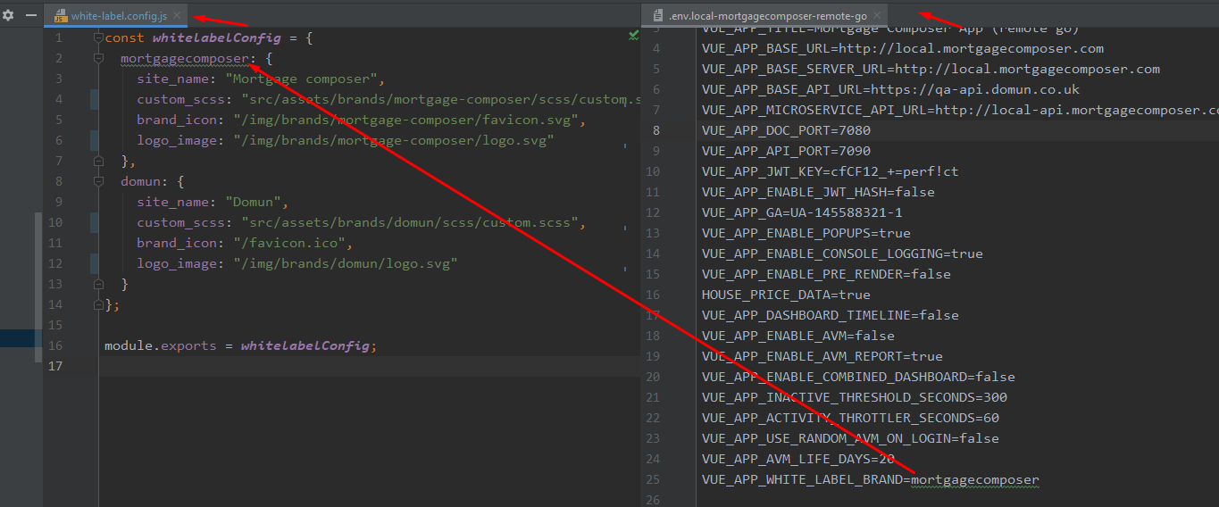

1. You can specify site name by setting site_name field in corresponding brand in white-label.config.js.  
   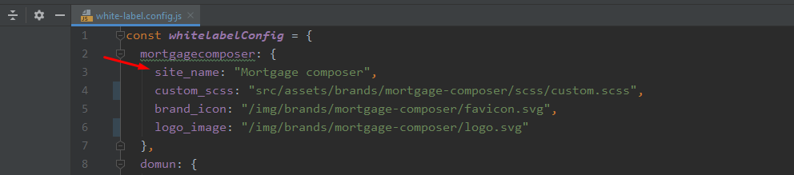
2. You can specify brand icon by setting brand_icon field in corresponding brand in white-label.config.js.  
   We should be aware root path is public folder and brand icon source should be inside public folder  
   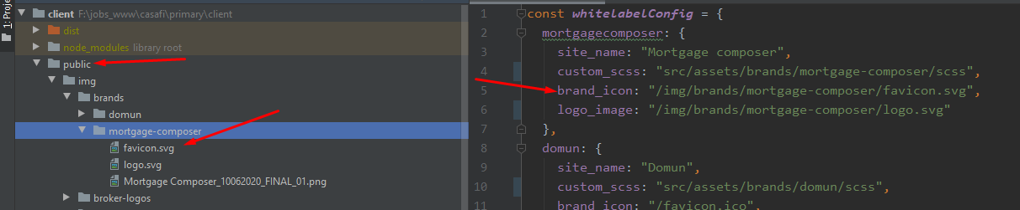
3. Specifying Logo image is identical just like brand icon. Just specify in logo_image

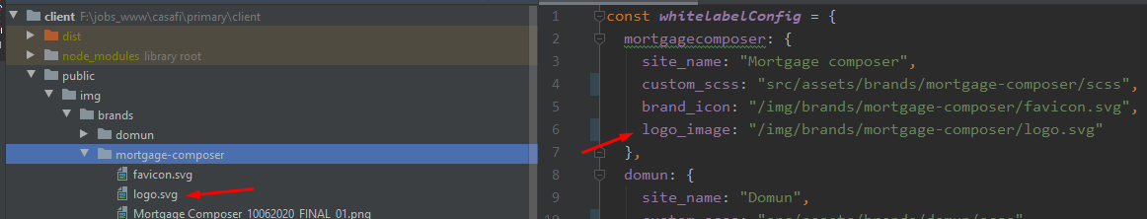

1. Customize specific style using custom_scss in corresponding brand in white-label.config.js

we will need to customize specific style per brand.  
For example, we will need to have logo size a bit larger on mortgagecomposer brand.  
That is why we have custom_scss field in white-label.config.js  
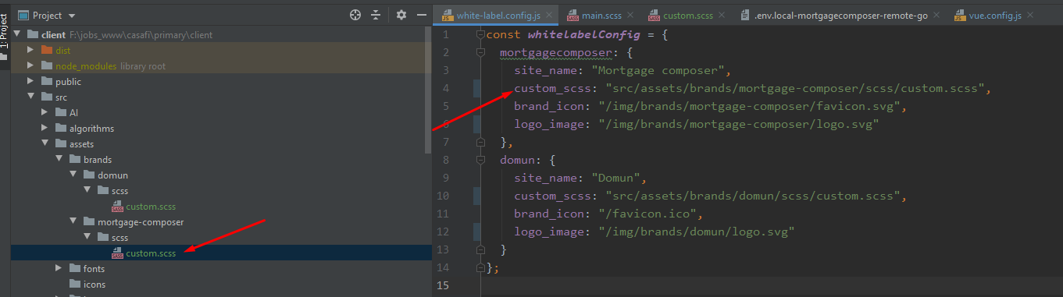

Adding new brand

We can add new brand in white-label.config.js and specify that brand in used env.  
  
Hope this will make sense 😊